COSC 264 Part 2 - Routing

ASN Autonomous System Number
These are a set of IPs that are managed by a single organisation.
They exchange information by using a common routing protocol and are connected.
Stub AS – has only one connection to another AS
Multi-homed AS – has more than one connection but doesn’t allow traffic to pass through
Transit AS – is connected to multiple AS’s and allows traffic to pass through.

Routing vs Forwarding
Routing determines the path to take from source to destination. Is not normally done per packet. Forwarding table is populated by routing. There are different types of routing algorithms. This takes around 2 minutes ish to compute a route, by routers talking amongst themselves.
Forwarding transfers traffic hop-by-hop. It is like which exits to take on a drive. Forwarding is done on a per packet basis. Each router decides where to send the packet.

Forwarding Table
Results from the execution of routing protocol (dynamic routing) or preconfigured (static routing).
On every packet this table is consulted and contains the next hop for where the packet should go.

Routing Algorithms
RIP Bellman-Ford (Distance-vector) Algorithm Intra AS
OSPF Dijkstra’s Algorithm Intra AS
BGP Bellman-Ford (Distance-vector) Algorithm Inter AS
Static – changes very slowly over time often as a result of human intervention
Dynamic – algorithm recomputes routes as topology or load on the network changes. Is more responsive to loops or oscillations in routes
Global – each router has a global knowledge (state) of the network.
Decentralised – no router has complete information about the network and must communicate with its neighbours for information.
Load Sensitive – link costs vary dramatically depending on the current level of congestion on the link.
Load Insensitive – internet routing protocols RIP/OSFP/BGP are all load-insensitive. This helps to stop oscillations between routes.
They try to find the least cost path, then the shortest path (measuring hops).
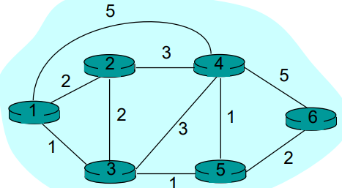

OSPF Dijkstra’s Algorithm or Link State Routing
Each router has a complete network picture (global routing)
Each router floods information about its neighbours to every other router, a bit like gossiping.
Flooding is dangerous as it can result in loops, called a Broadcast Storm.
Each router, after flooding can independently calculate the least cost path from itself to every other router. It then can generate a forwarding table for every destination.
Method
S: nodes whose least-cost path already known
S = { u } where u is source node initially.
D(v) = c(u, v) for all nodes adjacent to u
D(v) = infinite for all other nodes, this is updated as shorted paths are learnt
P(v) is predecessor node, i.e. the node that is right next to v.
Key Step is:
D(v) = min{ D(v), D(w) + c(w, v) } where w is the node that is going to be added to S
The complexity of Dijkstra’s Algorithm is n(n-1)/2 comparisons so is O(n^2) as need to check all nodes, w, that are not in S.
This can be reduced to O(n log n) (or O(log(n!)) ) by using a min-heap as this finds the node with the min cost in O(log n) time. See Stirling's Estimation.

Distance Vector Algorithm (Bellman-Ford)
Dynamic, decentralised (distributed), load-insensitive normally, asynchronous
Define cost of least-cost path from to then we have:
This is done for all neighbours of source node
Can also detect if there is a negative cycle, for example a link/path with negative cost.
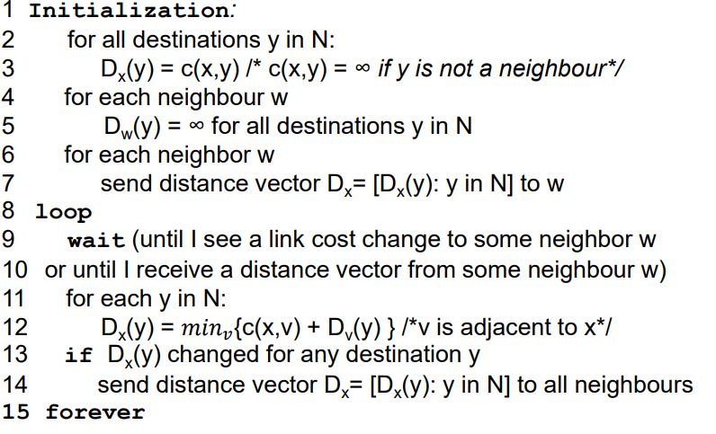
In practice we will use estimates:
is estimate of least cost path from to . Over time all the nodes share their own estimates with each other. Over time these estimates will converge to the correct distance .
Only notify neighbours when your Distance Vector changes. The entire path is never known just which next hop to take.
RIP allows at most 25 nodes to be stored (subnets).
Wait→recompute→notify
|-----------←-------------|
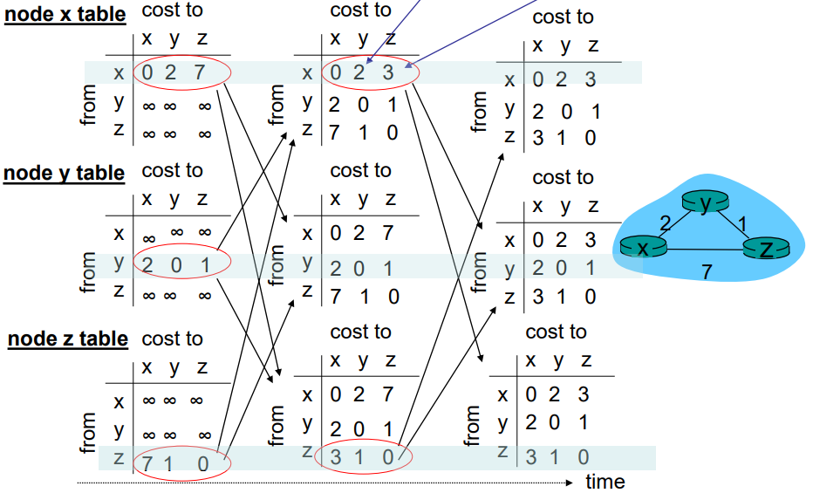

Detecting a link cost change
Good news travels fast, links get quicker:
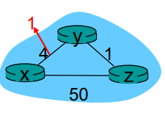
At time t=0, y detects the link-cost change (4 → 1), updates its DV,and informs its neighbors.
At time t=1, z receives the update from y and updates its table.It computes a new least cost to x (5 → 2) and sends its neighbors its DV.
At time t=2, y receives z’s update and updates its distance table. y’s least costs do not change and hence y does not send any message to z.
When times get longer then the path update is a bit more complicated. Bad news travels slow.
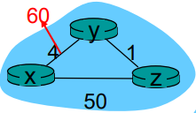
Initally 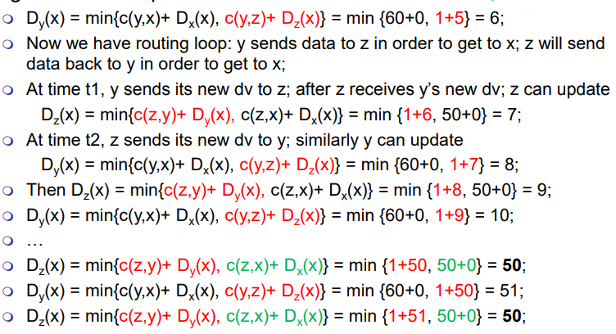
Y and Z keep trying to send data to each other to get to send, this causes oscillations back and forth until eventually they discover that this is not the best way to do it. However what if instead of 60 and 50 it was 10,000 and 9,999. We have a count to infinity problem.

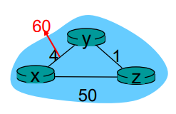
Poisoned reverse:
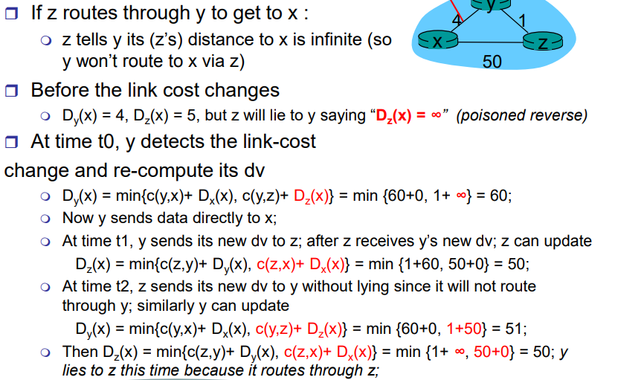
Z will lie to Y about its distance to X () as it goes through Y to get to X.

Poisoned Reverse is not perfect, doesn’t solve everything.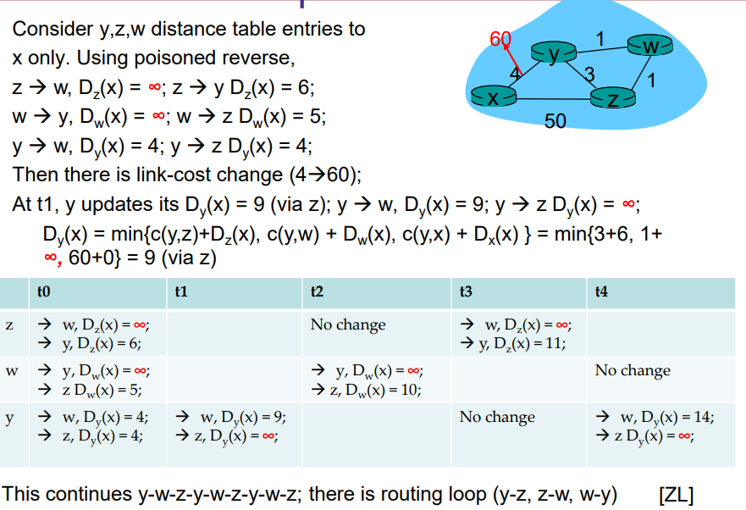
In RIP the maximum cost/length of a path is limited to 15 so the count to infinity problem is not too bad.

Summary Link State (Dijkstra) and Distance Vector (Bellman-Ford)
Message Complexity and Speed of Convergence
LS: with N nodes and E links; (although this can be reduced to by
using a mini-heap) that requires messages, may have oscillations
DV: exchange only between neighbours with varying convergence time, could be routing loops
or count to infinity (15 for RIP) problem
Robustness (What happens if a router malfunctions):
LS: node can advertise incorrect link cost but each node computes its own table
DV: node can advertise incorrect path cost and the error can propagate through the network.

NAT Network Address Translation
- no need to be allocated range of addresses from
- ISP: - just one IP address is used for all devices can change addresses of devices in local network without notifying outside world
- can change ISP without changing addresses of devices in local network
- devices inside local net not explicitly addressable, visible by outside world (a security plus).
On receiving outgoing datagrams swap source IP and port with NAT IP and new unused port. Add this to the table. On incoming datagrams swap destination IP and port to the one from the table.
However, is controversial as port numbers are made to address processes, NOT hosts. Routers should only process up to layer 3 and violates the end to end argument without a middleman. IPv6 should solve this instead.

IPv6
32bit address space is almost all used up. Header changes to increase forwarding speed and QoS. There is a fixed length header with no fragmentation allowed. Length is only size of the payload. Had next header field which contains the type of the next packet.
Conversion could happen on a flag day for example. Could use conversion but some data will be lost. Another option is using a tunnel; so, putting the entire IPv6 packet as the payload for an IPv4 packet!
CIDRised address, DHCP (dynamic host configuration protocol), and NAT has partially solved the IP address shortage, IPv6 has been very slow to adopt by the world.

Hierarchal Routing
Aggregate routers into ‘autonomous systems’ (AS). Routers within the same AS run the same routing protocol (intra-AS). Routers in different AS’s might run different protocols within them.
Gateway Router – Direct link to a router in another AS
Forwarding table is set by inter- and intra-AS routing protocols. Internal destination entries are only set by intra-AS routing, whereas external entries are set by both protocols.

Routing Information Protocol (RIP) Smaller Scale
Distance vector algorithm in 1982 version of BSD-UNIX. Has a maximum of 15 hops.
Number of hops = number of subnets traversed on shortest path to destination.
Information is exchanged every 30 seconds via a Response Message (called advertisements) using UDP. Each advertisement can list up to 25 destination nets within the AS.
Link Failure/Recovery. If no advertisements are heard for 180-seconds, then the link is declared dead. This error propagates quickly throughout the entire net. Poison reverse is also used to prevent loops, (infinite distance or 16 hops). This means count to infinity is count to 16.
Rather than storing DV of neighbours and their DV’s we just store a routing table. It contains enough info?

Open Shortest Path First (OSPF) Larger Scale
Open/publicly available. Every router contains global knowledge of the entire network. OSPF messages are carries directly over IP that are sent to the entire AS.
Features that are extra:
Security: all OSPF messages are authenticated
Multiple same-cost paths allowed (only one in RIP)
Link cost can vary on Type of Service, e.g. satellite link cost low for best effort and high for real time
Integrated uni- and multicast support, Multicast OSPF (MOSPF)
Hierarchical OSPF in larger domains
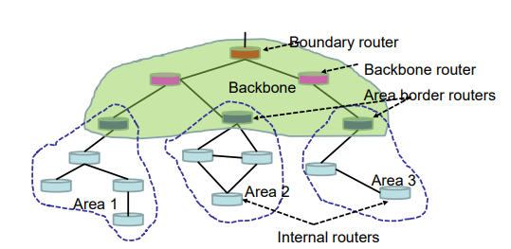
Two Level hierarchy: local area, backbone. Link state advertisements only for each area.
Area border routers: summarize distance to nets in its own area and let other area routers know
Backbone routers: run OSPF routing limited to the backbone
Boundary routers: these connect to other AS’s.

Internet Inter-AS routing: Border Gateway Protocol (BGP)
It is the de facto standard.
Pairs of routers (BGP peers) exchange routing info over TCP; BGP sessions, these do not have to be physical links.
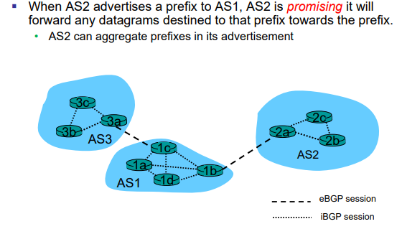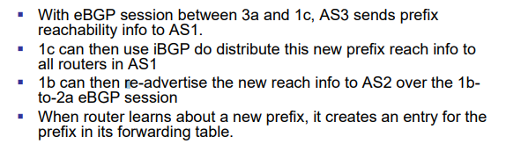
Each advertisement includes BGP attributes and a prefix.
AS-PATH contains the AS’s through which the advert for the prefix passed.
NEXT-HOP indicates the specific internal-AS router to next-hop-AS (return path)
BGP routing policy keep silent: means a router can just leech off the network and not do any routing/forwarding
BGP routing policy no freeriding: means that provider networks will only forward/route traffic that is coming from or destined to one of their customer networks.

Reliable Data Transfer

Error Detection

Types of errors Cause Solution
Bit error signal attenuation/noise error detection and correct
Buffer Overflow speed mismatch, lots of traffic flow and congestion control
Lost Packet buffer overflow at host/route ack and retransmission (ARQ)
Out of order an early packet get lost ack and retransmission (ARQ)
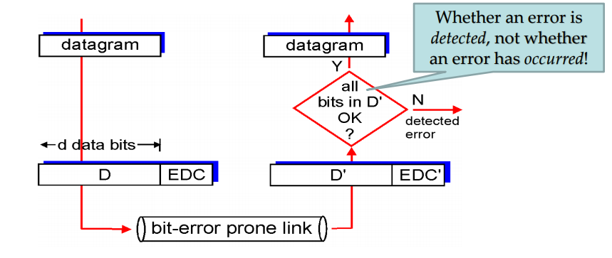
EDC – Error detection and correction D – Data protected by error checkiong, may include headers

Parity Check
Even Parity: 10000101 1 Odd Parity: 1001011 1
Add a 0 or 1 to make the number of one’s either even or odd.
An error can go undetected if an even number of bits are flipped.

2-D Parity Check
01110 1 Use a parity check on both the rows and the columns of the matrix.
01110 1 Is able to correct single bit errors, but if multiple occur in same row/column is
01000 1 impossible to tell.
01011 1 In this case we are using even parity.
00011 0
The ability of the receiver to both detect and correct errors is known as forward error correction (FEC).

Internet Checksum
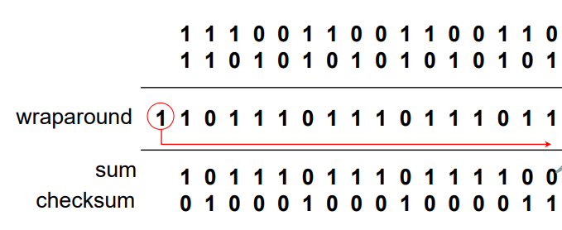
Treat segment contents as sequence of 16-bit integers. Add all of these segments contents together (1’s complement), this means that any carry over is added back to start. Checksum is the inverse of this sum.
This means summing the original data w/checksum will end up with all one’s.
It is considerably less effective than the cyclic redundancy check (CRC) – used at low level
However it is very efficient/fast and just checks end-to-end errors – just as a backup
Why do we need checksums at IP, UDP and TCP.
-IP just does header checksum, a double check; (no header checksum in IPv6).
-The celebrated end-to-end principle in system design:
- Some link-layer does not do error-detection
- Bit errors could happen anywhere (router’s memory)
- Certain functionality must be implemented on an end-to-end basis
- A final end-to-end check is always needed!

CRC Check
D = d-bit block of data
F = r additional bits (frame check sequence)
T = d+r bits to be transmitted
G = r+1 pattern of bits that is the predetermine divisor
We would like T to be divisible by G using modular 2 arithmetic.
This is just binary addition without carries, so is just XOR for addition and subtraction
To choose the remainder/additional bits
Called cyclic cause if we do a circular left shift then T is still divisible by G!!
Can use a polynomial to represent the pattern D, for example:

Forward Error Correction (FEC)
Error detection is not enough for wireless links as there is a high bit error rate and propagation delay.
Method:
Divide the message into blocks (blocking coding), each of k bits, called data words.
FEC encoder encodes data words, the resulting n bit blocks are called codewords.
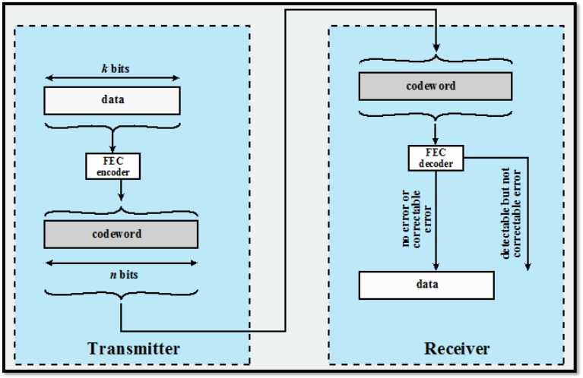
Example is 00→000, 01→011, 10→101, 11→110. Can only detect error, not fix in this case.

Hamming Distance
between two n-bit sequences, it is the number of bits in which and disagree.
We can do error correction by finding the minimum distance to the nearest codeword. Each codewords will be separated by the hamming distance.
Limitation is that if there is an equal distance from two codewords, the error cannot be corrected.
Error correcting ability is related to the minimum hamming distance.
Example
00 00000
01 00111
10 11001
11 11110
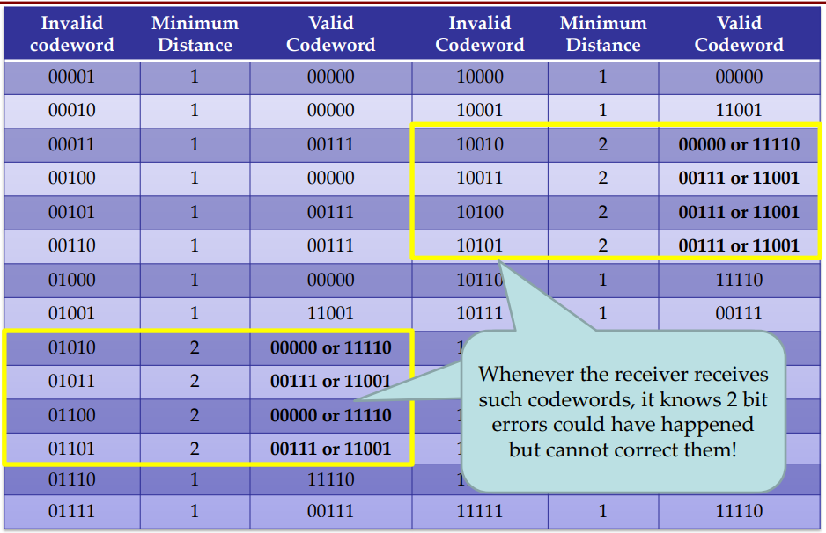

Automatic Repeat reQuest (ARQ) Protocols
Alternating bit protocol
Go-Back-N
Selective Repeat
RDT = reliable data transfer protocol

RDT 1.0 Perfectly reliable channel
No bit errors, no buffer overflows, no out-of-order, no packet loss.

RDT 2.0 Reliable but has only bit errors (no packet loss)
Sometimes certain packets need to be resent as the receiver cannot decode the message and sends an error acknowledgment.
Sender sends data and waits for a NAK/ACK. If receives NAK then resend packet
Receiver if packet received without errors send ACK, if there are errors send NAK.
This is known as stop-and-wait protocol.
Has a fatal flaw that if the ACK or NAK is corrupted then the receiver does not know whether we have a retransmission or a new message (great – great – grandson).

RDT 2.1 solve retransmission versus new data problem
Same as above, however uses a 1-bit sequence number to indicate a retransmission.

RDT 2.2 a NAK-free protocol
Instead of sending a NAK repeat the previous ACK (keep the sequence number the same to indicate repeat transmission)

RDT 3.0 Reliable data transfer over a lossy channel with bit errors!
Can have data/ACK loss and data/ACK delay. Also known as alternating bit protocol
To detect packet loss. Wait, wait and wait. How long should we wait for a response?
Too short – duplicate packets or Too long – decreased performance
Use timeout to detect packet loss, if time runs out then we just retransmit.
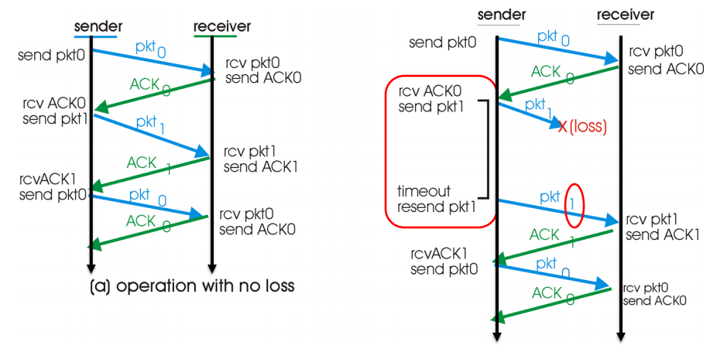
NOTE: if we receive a duplicate (or old) ACK then just ignore it, this is due to premature timeout.
RDT3.0 Has a major performance problem as it is a stop and wait protocol. This results in large RTT.
packet size round trip time transmission rate

Pipelining
Send multiple packets at once without waiting for ACK. Uses sequence number of bits
Sender and receiver may have to buffer multiple packets.

Go-back-N protocol – Windowing
The sender can send multiple packets without ACK up to a certain number N into the pipeline.
Base seq # is the oldest not confirmed packet
If N needs to balance overflow/congestion with utilization/performance.
Cumulative ACK:
When an ACK is received then the transmitted knows that all packets up to the sequence number of the ACK have been received correctly.
Receiver rule is that if any packet is received out of order/sequence then discard it and resend an ACK for the most recently received in-order packet! Causes lots of retransmission!
Timeout:
When a timeout occurs resend all non-ACK’d packets

Selective Repeat/Reject
Receiver will individually acknowledge all correctly received packets.
Sender only resend packets for when ACK is not received.

We assume that a packet will not be reordered within the channel between the sender and the receiver, as need to give a limited lifetime of a packet. This could happen on a multi-hop path.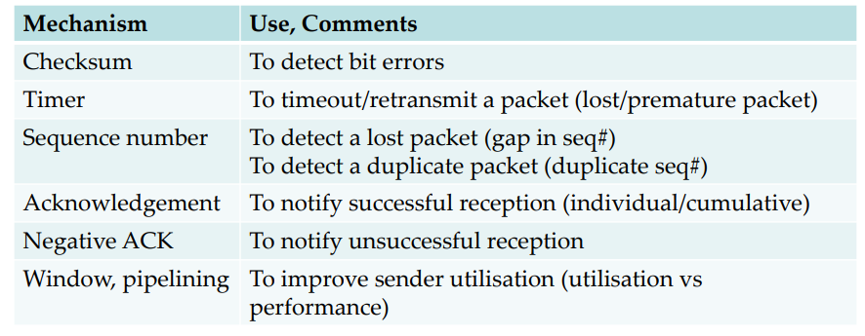

TCP Reliable Data Transfer
TCP uses a mixture of Selective Repeat and Go-back-N.
TCP uses segments with a sequence number to get the appearance of end-to-end
TCP can use collective ACK, saying have received all of the bytes up to a certain number.
A timeout is also used to detect when packets are lost entirely.
When timeout expires, only send packet with smallest unack’d sequence number, not all! Also double the timeout interval as there could be congestion so try and slow down the sending process.
Whenever an ACK or call from above, reset the timeout value to initial value.

Fast retransmit
If sender receives 3 ACK’s for the same data, it supposes the segment directly after ACKed data was lost. It then resends this data before the timeout even expires. This is the ability to detect lost segments by many duplicate ACK’s.

Summary
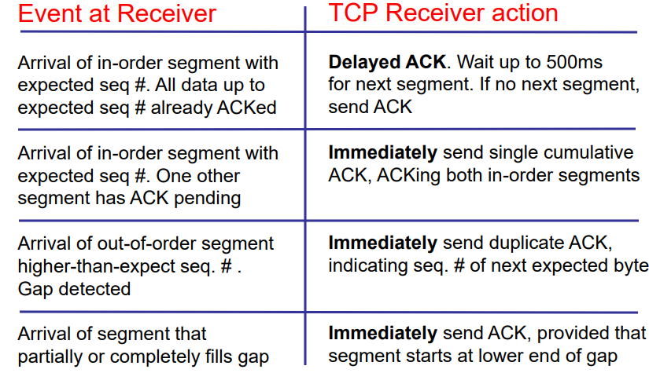

Setting the timeout value
Should be bigger than the Round-Trip Time of a packet. If it is too long, we will have slow reaction to segment loss, if it is too fast, we will have unnecessary retransmissions. To estimate this, we send a sample segment and measure the time it takes to send an ACK. Use this formula:

This is known as exponential weighted moving average (EWMA) and typically . Influence of past samples decrease exponentially fast.
To get the actual value we first get the deviation using: (where

TCP Flow control
Only concerns two parties, the sender and the receiver.
Keeping the number of unACK’d segments in the channel low.

is for congestion control and is for flow control.

Congestion Control
Treats the root of packet loss. Is about slowing down for the network as a whole.
Stop overflows in a shared router/mid hop host
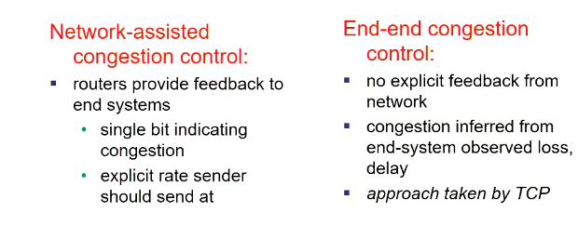
TCP uses end-end congestion control.
Causes/costs of Congestion:
- Sending too much data too fast for the network to handle
- Two connections share one router causing a bottle neck causing a buffer overflow
- Can also mean that a packet is dropped near end of journey causing earlier waste of resources.
Within one RTT, the sender sends at most bytes. Assuming flow control is negligible.

To detect and reduce the we detect either a timeout or 3 duplicate ACKs, so lost packets.
Treat the arrival of ACKs as a indication of congestion: if they are fast – increase fast, if they arrive slow – increase slowly, and if there is timeout/duplicate ACK’s decrease .
Additive increase, multiplicative decrease, slow start and reaction to timeout
1MSS is a max segment size.
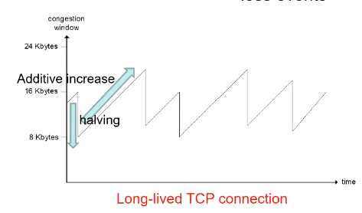
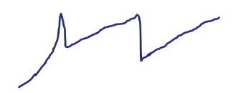
Every sender starts at as
As ACK’s are received add 1 to the – exponential increase because as it gets bigger increases more.
As soon as we get the FIRST loss of packet halve the .
Now only increase by one every
TCP has refined actions towards a loss event, depending on where it is a timeout or 3 dup-ACKs.
3 dup-acks the network means network can still send some data.
Timeout means network is dead and is more alarming
After 3 dup-ACK’s cut window in half.
After timeout, set to 1MSS, window grows exponentially up to a threshold, which is half of the before timeout.